**Zoyac**

*Mini Project* *Report*

by

**Y.ASARUDDEEN**(TU6220204112002)

**M.ARTHI**(TU6220204111001)

**D.HARISH**(TU6220204111003)

School of Computer Science

*Submitted to* the

**SCHOOL OF COMPUTER SCIENCE**

*in partial fulfillment of the requirements for the award of the degree*

**BACHELOR OF COMPUTER APPLICATION**



*Submitted to the*

**FACULTY OF** **SCIENCES**

**SCHOOL OF COMPUTER SCIENCE**

**TAKSHASHILA UNIVERSITY**

Ongur, Tindivanam.

**JULY – 2024**

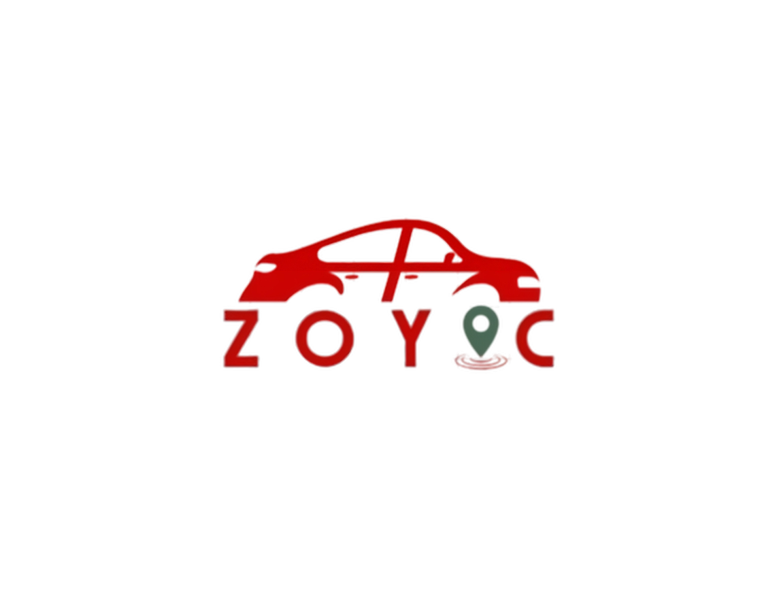

**Y.ASARUDDEEN**(TU6220204112002)

**M.ARTHI**(TU6220204111001)

**D.HARISH**(TU6220204111003)

**ABSTRACT**

The **Zoyac** project aims to design and develop an efficient, user-friendly platform that bridges the gap between taxi service providers and passengers. In an increasingly connected world, the need for reliable and easily accessible transportation services is paramount. **Zoyac** acts as an intermediary, allowing users to book taxis from various service providers through a single, integrated platform.

The platform provides a seamless experience for both taxi operators and customers. Key features include a user-friendly interface for booking rides, real-time updates on availability, fare estimation, and automated payment processing. Additionally, the system will offer a robust backend for taxi companies to manage their fleet, track performance metrics, and optimize operations.

The project employs a combination of software engineering principles, database management, and network communications to ensure reliability, scalability, and security. By simplifying the process of booking a taxi and enhancing operational efficiency, **Zoyac** aims to revolutionize the traditional taxi industry and provide a competitive alternative to ride-sharing services.

**REQUIREMENTS**

**Software Requirements:**

|  |  |
| --- | --- |
| Operating System | Windows 11 Pro |
| Front End | HTML, CSS, JavaScript ,Bootstrap |
| Back End | Python |
| Program | Python |
| IDE | PyCharm |
| Framework | Flask |
| Database | MySQL |
| Server | Local Server |
| System type | 64-bit operating system |

**Hardware Requirements:**

|  |  |
| --- | --- |
| System | PC/Laptop/Mobile |
| Processor | Intel Core i3 / Intel Core i7/Dimensity 7050 |
| RAM | 8.00 GB / 16.00 GB |
| ROM | SSD(512 GB) |
| Speaker | High-quality speaker |
| Mouse | Touch screen , Track pad |
| Graphics card | NVIDIA GeForce GTX 1660 |